Practical -1
- Measures = numbers
- Measures mostly store in fact tables
- dimensions are stored in dimension table
- dimensions describe what actually measure means
- fact table consists primary keys in maximum cases

Star schema
- it consist of fact table, dimension tables
- dimension tables give more context about fact table
- tables connected with simple foreign key relationship
- it is pure denormalised design
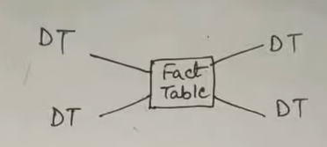

Snowflake schema
- it is same as star schema but the change is dimension tables are normalised
- one dimension table connected to another dimension table is possible
- if we want more detail information then we connect one dimension table with other
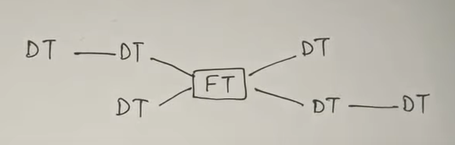

fact Constellation Schema
- it has collection of fact tables
- it has more than one fact table
- one dimension table may connect more than one fact table
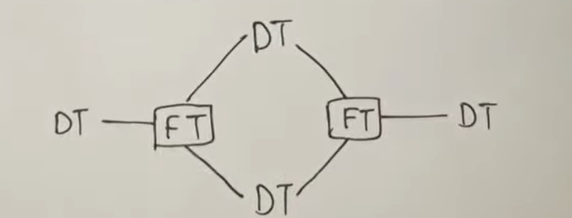

difference
